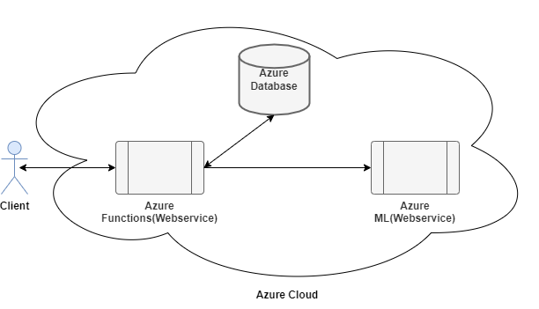

**Background:**

This is a Service for Credit card Transaction validation in Azure Machine Learning. We have trained the ML Service with the Credit card Data.

We have a Azure Function Wrapper Service on Top which acts as a proxy. It sends the request to the Azure ML webservice, and passes the response back to the client.

We have a DB Table in MySQL on Azure where the Status of each transaction is Stored, the Azure Function Webservice stores the status to the DB.

The Functional Flow diagram is as explained above.

**The step by step process is explained below: -**

* User invokes the Azure Function Webservice with the JSON Data.
* Webservice passes through the input data to the ML Webservice and gets the response back.
* Makes status updates to the MYSql DB.
* Returns the Success/ Failure response back to the Azure Function client.

**Webservice Invocation in Postman:**

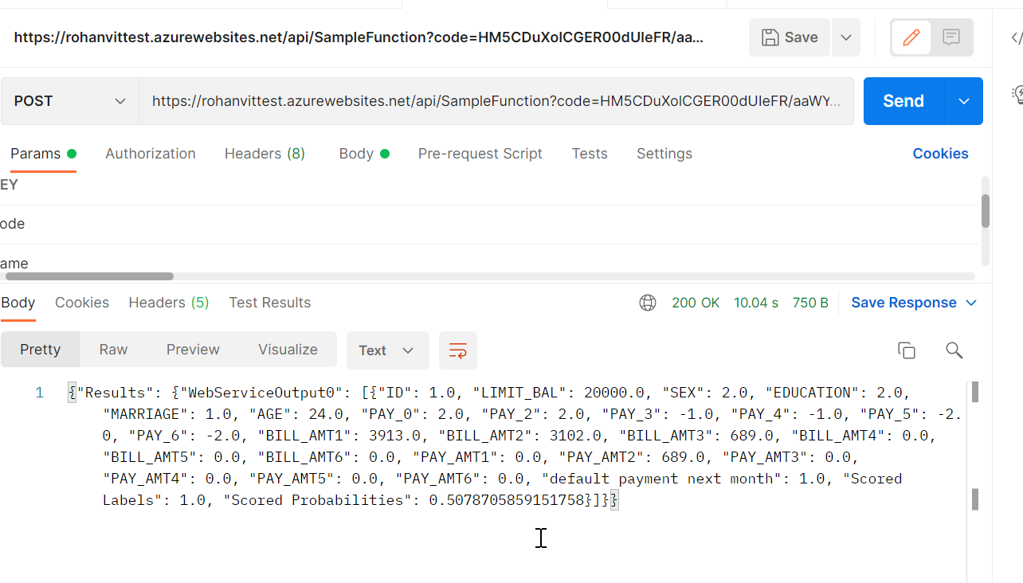

**URL with request Parameters:**

https://rohanvittest.azurewebsites.net/api/SampleFunction?code=HM5CDuXolCGER00dUIeFR/aaWY3HjFjJttimGjUvV6jrealKzJLFMA==&name=Rohan&data={

"Inputs": {

"WebServiceInput0": [

{

"ID": 1,

"LIMIT_BAL": 20000,

"SEX": 2,

"EDUCATION": 2,

"MARRIAGE": 1,

"AGE": 24,

"PAY_0": 2,

"PAY_2": 2,

"PAY_3": -1,

"PAY_4": -1,

"PAY_5": -2,

"PAY_6": -2,

"BILL_AMT1": 3913,

"BILL_AMT2": 3102,

"BILL_AMT3": 689,

"BILL_AMT4": 0,

"BILL_AMT5": 0,

"BILL_AMT6": 0,

"PAY_AMT1": 0,

"PAY_AMT2": 689,

"PAY_AMT3": 0,

"PAY_AMT4": 0,

"PAY_AMT5": 0,

"PAY_AMT6": 0,

"default payment next month": 1

}

]

},

"GlobalParameters": {}

}

**Output Response:**

{"Results": {"WebServiceOutput0": [{"ID": 1.0, "LIMIT_BAL": 20000.0, "SEX": 2.0, "EDUCATION": 2.0, "MARRIAGE": 1.0, "AGE": 24.0, "PAY_0": 2.0, "PAY_2": 2.0, "PAY_3": -1.0, "PAY_4": -1.0, "PAY_5": -2.0, "PAY_6": -2.0, "BILL_AMT1": 3913.0, "BILL_AMT2": 3102.0, "BILL_AMT3": 689.0, "BILL_AMT4": 0.0, "BILL_AMT5": 0.0, "BILL_AMT6": 0.0, "PAY_AMT1": 0.0, "PAY_AMT2": 689.0, "PAY_AMT3": 0.0, "PAY_AMT4": 0.0, "PAY_AMT5": 0.0, "PAY_AMT6": 0.0, "default payment next month": 1.0, "Scored Labels": 1.0, "Scored Probabilities": 0.5078705859151758}]}}